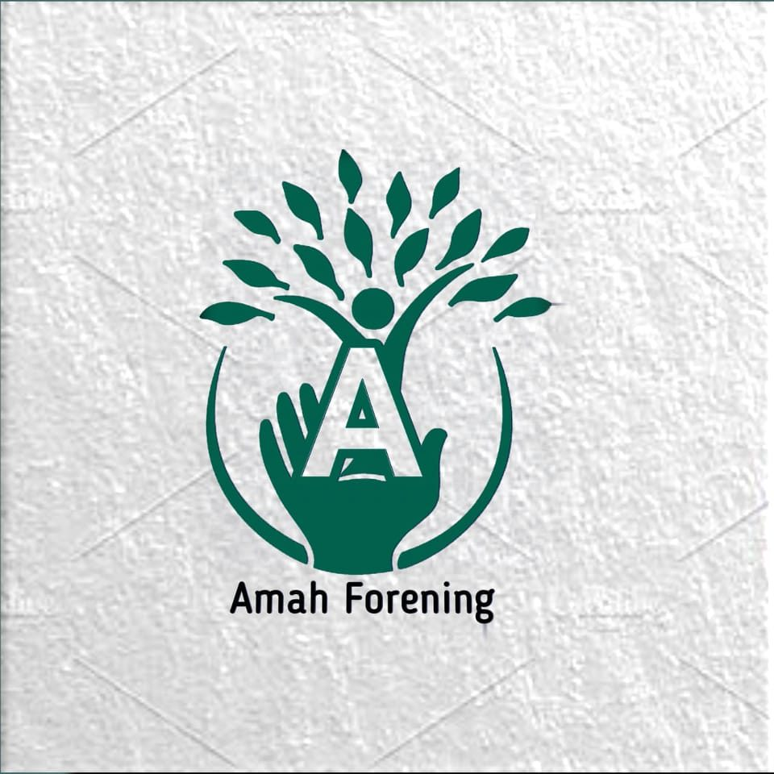


Empowering immigrants Young People for Democratic Engagement
Day  Time | Monday  07.12 | Tuesday  08.12 | Wendesday  09.12 | Thursday  10.12 | Friday  11.12 | Saturday  12.12
8:00  9:30  .  .  .  .  .  .  .  .  .  .  .  .  13:00 | A  R  R  I  V  A  L  S | BREAKFAST | BREAKFAST | BREAKFAST | BREAKFAST | BREAKFAST
8:00  9:30  .  .  .  .  .  .  .  .  .  .  .  .  13:00 | A  R  R  I  V  A  L  S | Intercultural learning, group building, expectations, identity and diversity, inclusion and equality, safe-space creation, democratic participation, active listening, and getting to know the different backgrounds and experiences of participants. | Democratic values and principles, human rights, citizenship and responsibilities, elections and voting, political and civic institutions, European values, rule of law, equality and non-discrimination, youth participation, and opportunities for young people to engage in democratic life. | Communication skills, public speaking, storytelling, confidence building, media literacy, digital citizenship, critical thinking, identifying misinformation and disinformation, expressing opinions respectfully, overcoming language barriers, and understanding barriers to participation. | Community mapping, identifying local needs and challenges, understanding decision-making processes, advocacy and campaigning, stakeholder mapping, developing messages, community outreach, social media for civic engagement, youth-led solutions, project planning, and transforming ideas into concrete actions. | D  E  P  A  R  T  U  R  E  S
13-15 | LUNCH | LUNCH | LUNCH | LUNCH | LUNCH | D  E  P  A  R  T  U  R  E  S
15:00  .  .  .  .  .  .  .  .  .  .  .  .  .  .  .  .  19:30 | A  R  R  I  V  A  L  S | Connecting and Understanding: Intercultural learning, group building, expectations, and democratic participation | Inclusive leadership, teamwork, intercultural dialogue, conflict management, negotiation, empathy, active listening, facilitation, dealing with stereotypes and discrimination, challenging negative narratives, building partnerships, leadership styles, and developing effective youth-led initiatives. | Development of personal and community action plans, presentation of youth-led ideas, peer feedback, networking, reflection and evaluation, dissemination planning, peer-to-peer learning, multiplier roles, follow-up commitments, identifying future. | follow-up commitments, identifying future opportunities for participation, and creating connections for continued cooperation after the training. | D  E  P  A  R  T  U  R  E  S
15:00  .  .  .  .  .  .  .  .  .  .  .  .  .  .  .  .  19:30 | Welcome | NETWORKING AND WELCOME DINNER | Group Discussion | Group Discussion | Closing session | D  E  P  A  R  T  U  R  E  S
20-21 | DINNER | NETWORKING AND WELCOME DINNER | DINNER OUT | DINNER | DINNER | D  E  P  A  R  T  U  R  E  S
21:30 | Free Night | Free Night | Free Night | Free Night | Sharing moments | D  E  P  A  R  T  U  R  E  S

